Azure DevOps Setup Manual

Contents

Setup your Azure DevOps 2

1.1. Fresh AzureDevOps Login 2

1.2. Setup a new Organization in existing Azure DevOps Account 6

Please Setup your Azure DevOps Account before the Hackathon and feel free to Contact us if you need any Help during the Process.

Setup your Azure DevOps

* 1. Fresh AzureDevOps Login

If you never Used Azure Devops before use this one.

1. Login to your Capgemini Account under <https://dev.azure.com/>
2. If you are Already Logged in Skip the Next Step
   1. Click “Sign in” on the Top Right Corner  
      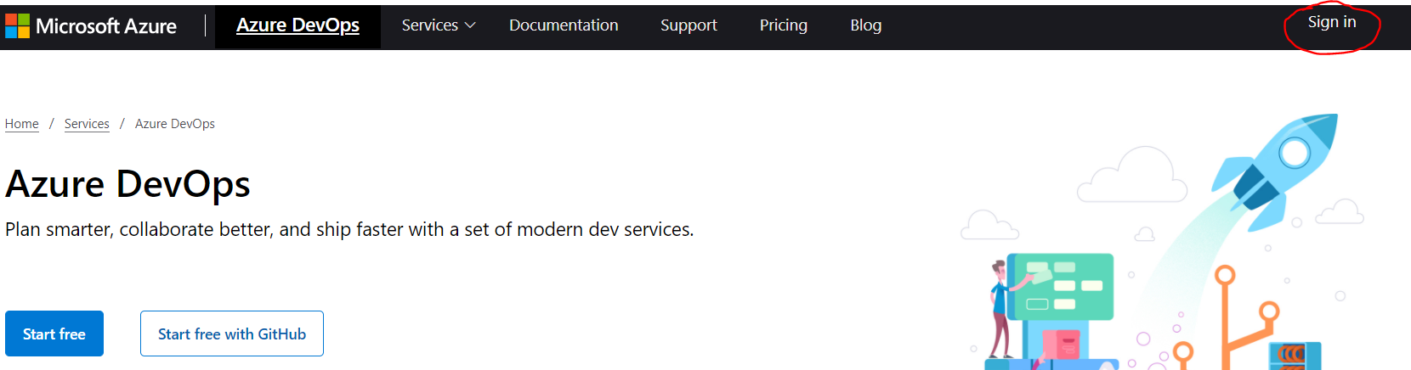
   2. Select your Organisation Account or enter your Company Mail Adress  
      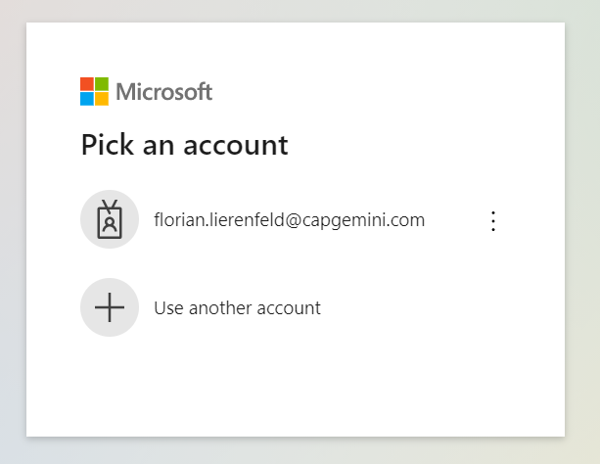
   3. You are Redirected to Capgemini Login  
      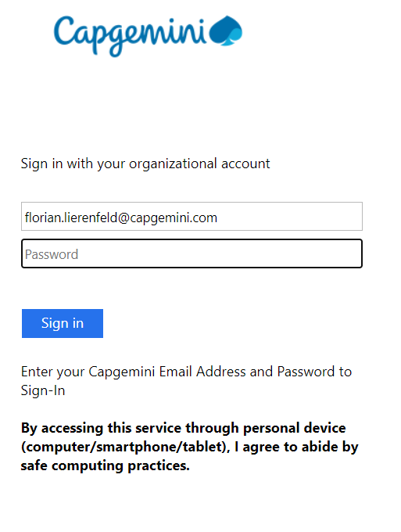
3. When you are Successfully Signed in you are Redirected to <https://dev.azure.com> again where you can select “Start Free”  
   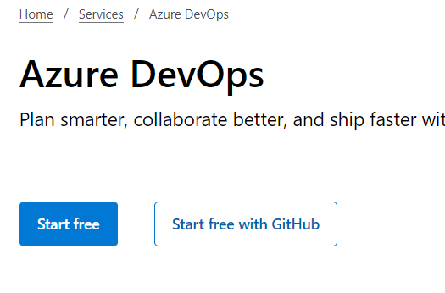
4. Next you can Setup your Azure DevOps Account  
   Select a Unique Name for your Project, Set it to Private and enter the Capture.  
   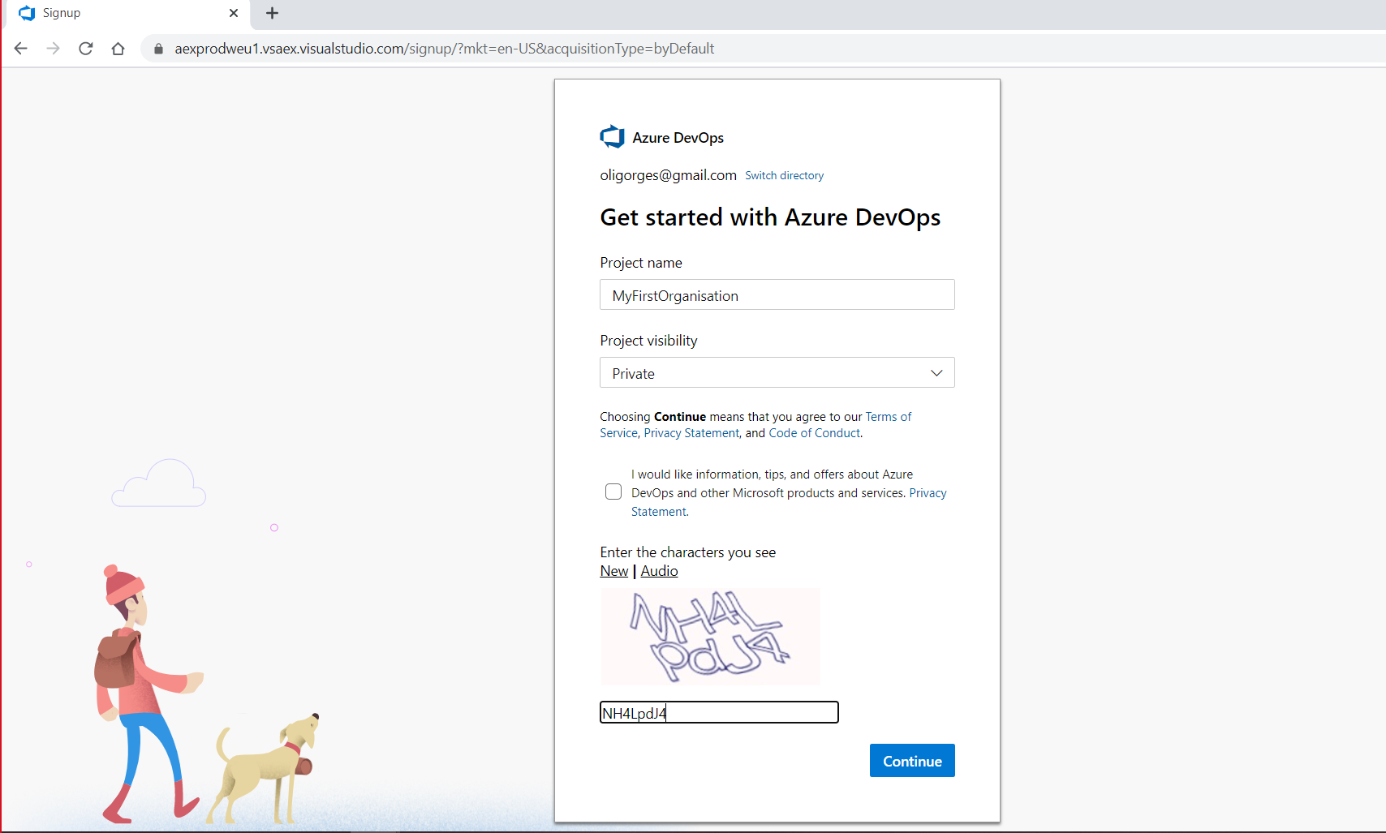
5. Your Project will be Created  
   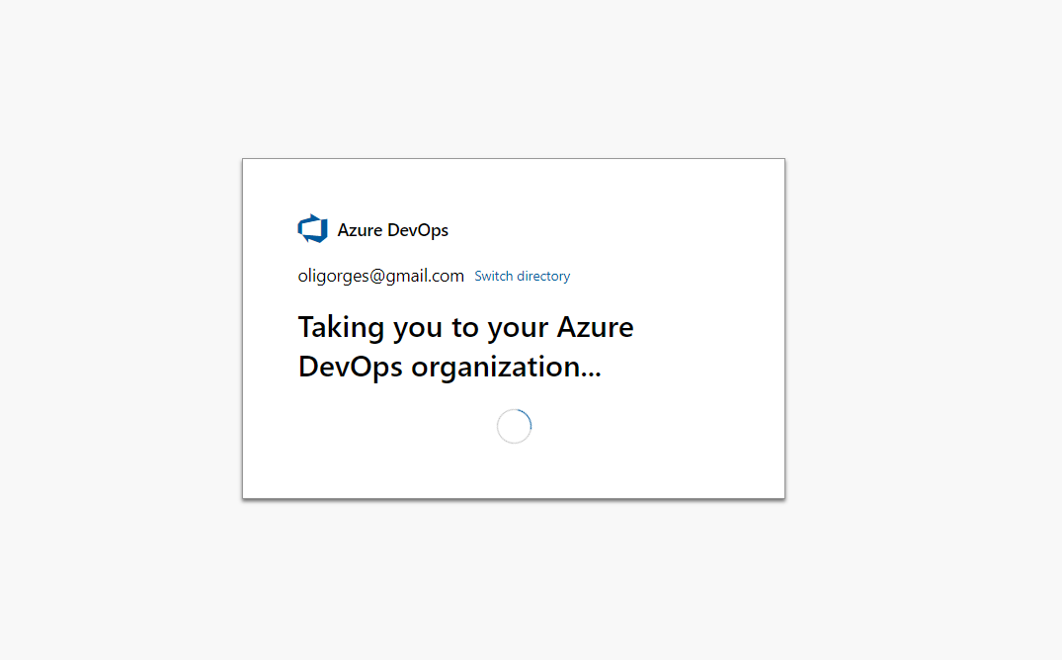
6. Your Organisation is now Setup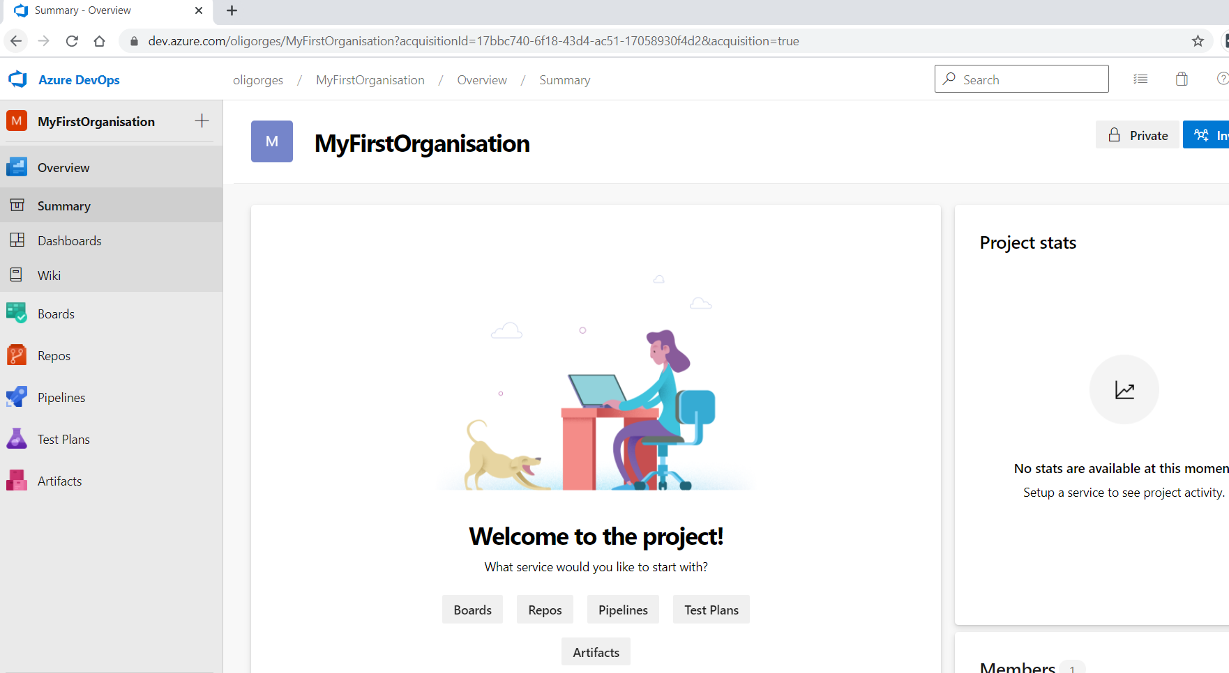
   1. Setup a new Organization in existing Azure DevOps Account

If you used Azure Devops before and don’t have your own Organization Setup, you can Login at <https://dev.azure.com> and Select “Create new Organization” on the Right side.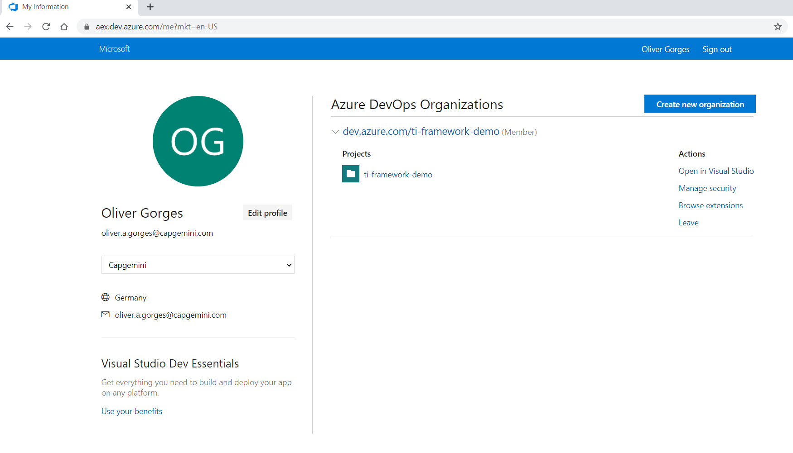

1. Click “Continue”  
   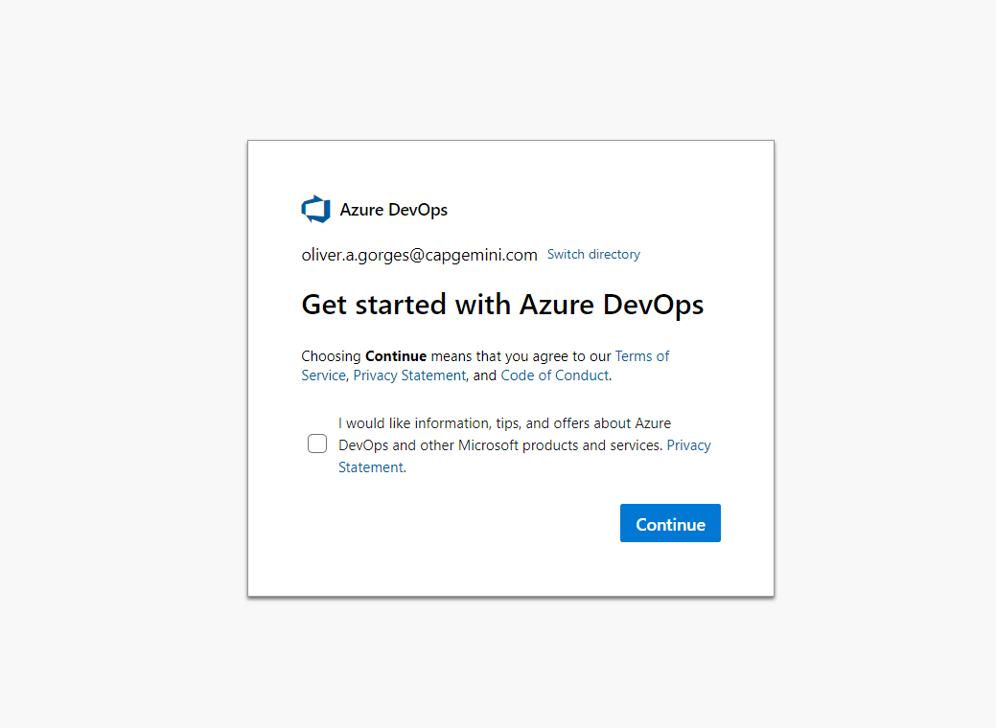
2. Select a unique Name for your Organization and Select a Region next to you.  
   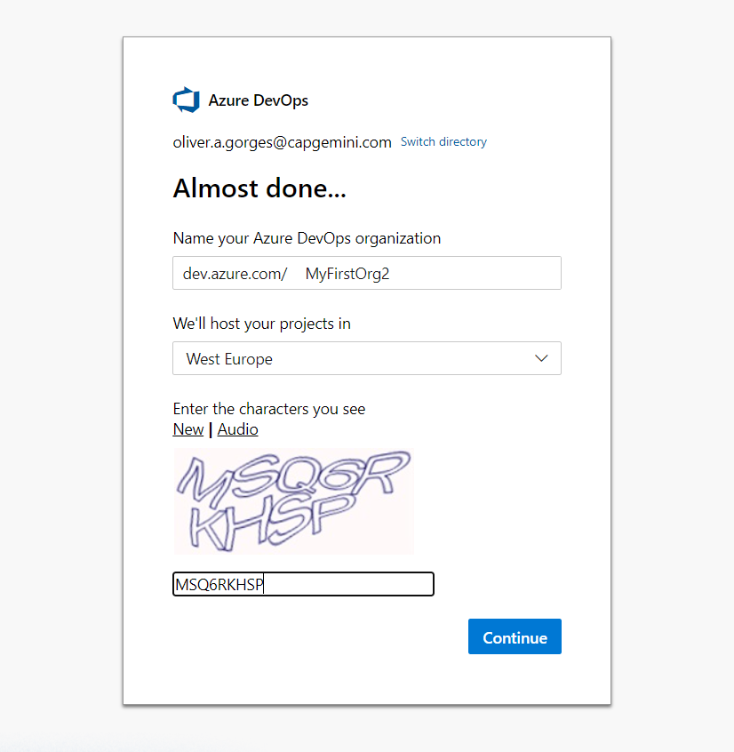
3. Your Organization is Setup  
   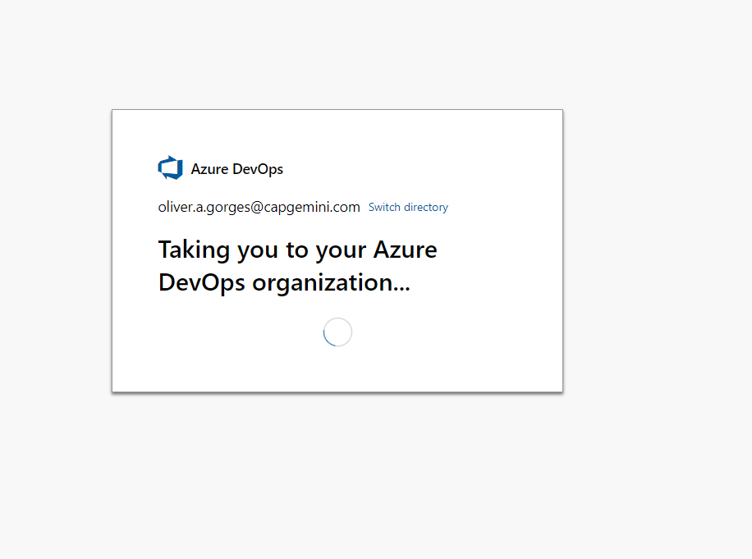
4. Create your first Project  
   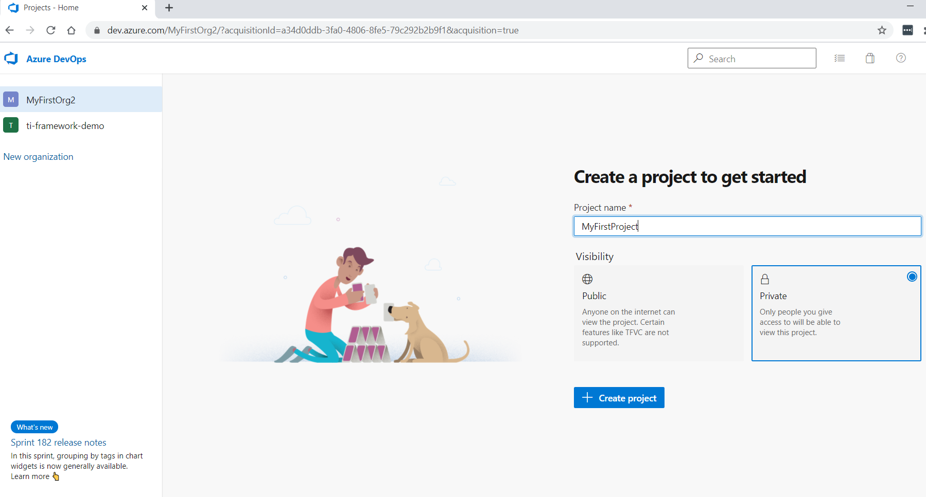
5. Your Site is Setup  
   